Roman Numerals: A Geometric Story
Idea by Alexander Vyunik
This is an author's geometric model, not a school textbook. Try drawing each numeral yourself and see whether you notice what I notice.

The cross and the quadrant
Draw a cross: one horizontal line and one vertical line. It splits the plane into four parts. Each part is called a quadrant. Half of a quadrant is called a quadramin.

Dots: I, II, III, IIII
A dot is the simplest unit of counting and dividing. One dot is I, two dots are II, three are III, four are IIII. This is how people counted before numerals existed: they simply made marks.
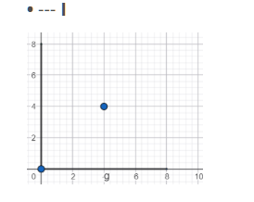
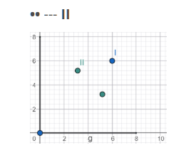
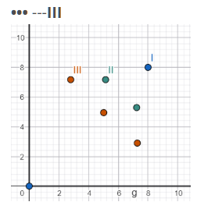
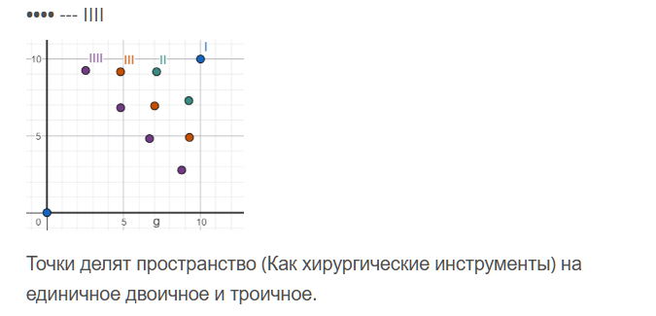

V: a quadrant with five angles
When there are many dots, a new unit is needed. Imagine a quadrant divided into equal angles. The basic version has 5 angles, and that is V. The first angle is harder to notice than the others, but it is there.
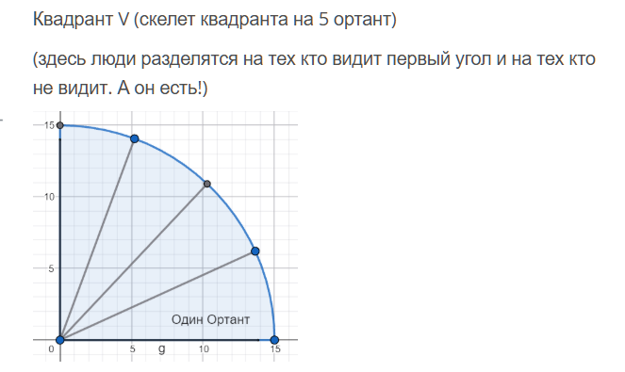
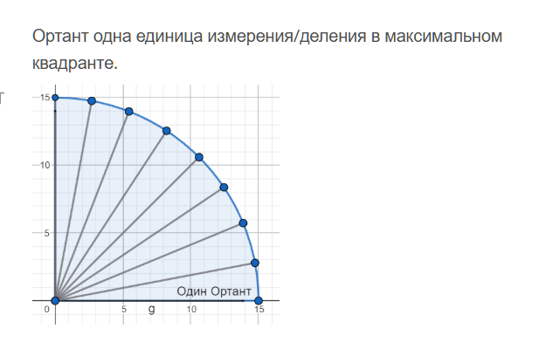

IV: a special figure
In this model, four has its own shape: an incomplete quadrant with three equal angles and a small arrow on its left side, equal to one angle. The author calls it a trigrant. It looks like a quadrant, but it is not as whole.
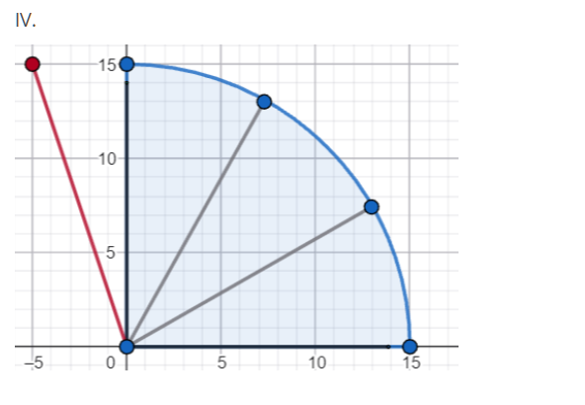

VI, VII, VIII
We add one angle at a time to the quadrant: 6, 7, 8. At eight angles the quadrant is filled to the limit.
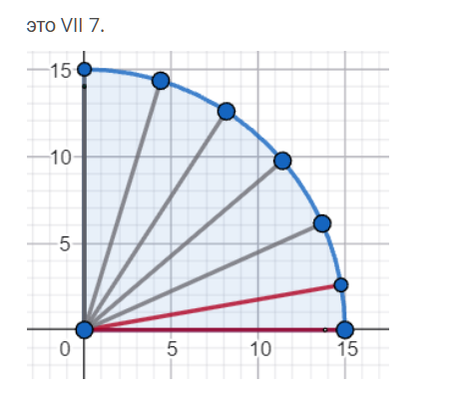
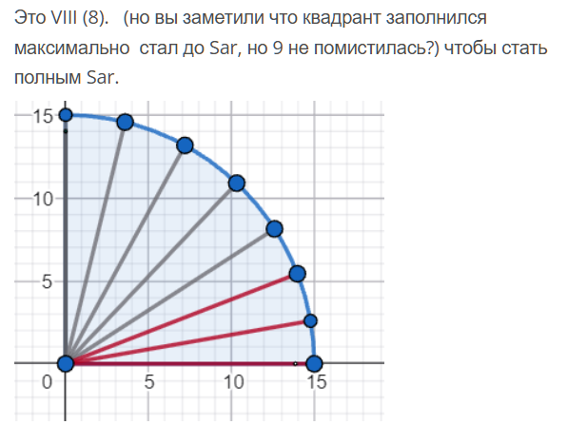

IX
The quadrant is full (8 angles), but one step is still missing before SAR. Nine stands right before ten.
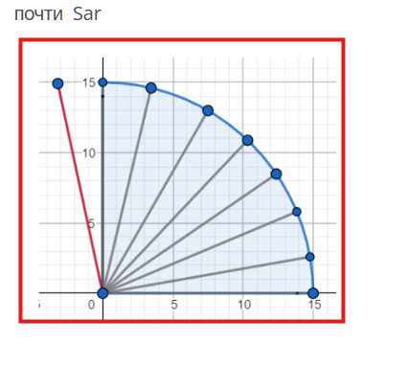

X (SAR)
Two quadrants together: V + V = X. In this model the ten is called SAR (a name introduced by the author).
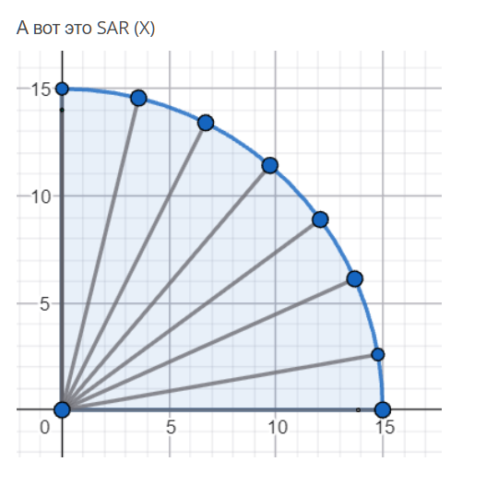

Invitation
If you would like to discuss this idea, write to me: piksession@mail.com

